**DevOps- Task 2**

**How to save changes in image?**

To save changes of the docker images. We need to commit those changes & save it as a new image. This document contains all those commands which are necessary to save an image & cleanup resources.

**Starting Docker:**



In the above image, I have started docker.

**Download & Run Ubuntu latest image:**



In the above image, I have installed Ubuntu image.

**Image Version:**

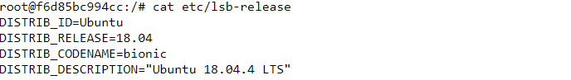

In the above image, we can see the ubuntu version.

**See current Running Images:**



**Listing image files:**



In the above image, we can see the files inside ubuntu default directory.

**Create file in Docker:**



In the above image, I have created new file by name “FILE_NAME”.

**Docker exit to an Image**



In the above image, I have exited to the docker image.

**See last running Image:**



In the above image, we can see the last running image.

**Commit Docker Image:**



In the above image, I have committed the changes in above image.

**Docker Images:**

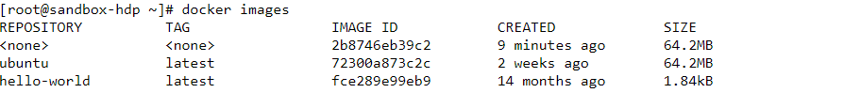

In the above image, we can see the committed image is remain unnamed. Creating an unnamed image is not a good approach.

**Give name to Docker Image:**



In the above image, I have given the image name.

**Docker Images:**



Now, we can see the docker images.

**Docker file is present in Committed image:**



Finally, our commits have been saved.

**Directly Commit Image by Name:**

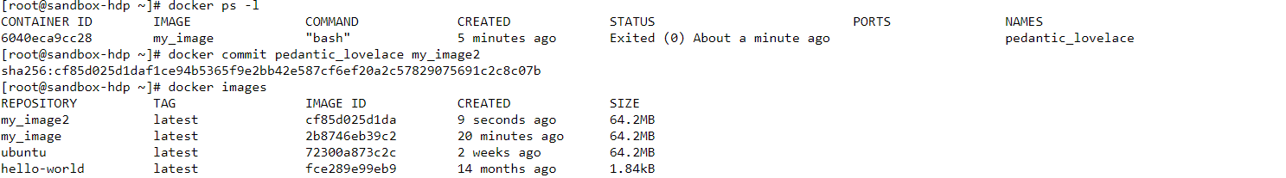

This is the simpler way to commit an image with a new name.

**Docker Stop Container:**

Kill command is used to stop containers.

docker kill cf85d025d1da

docker kill 2b874eb39c2

docker kill 72300a873c2c

**Docker Cleanup Resources:**

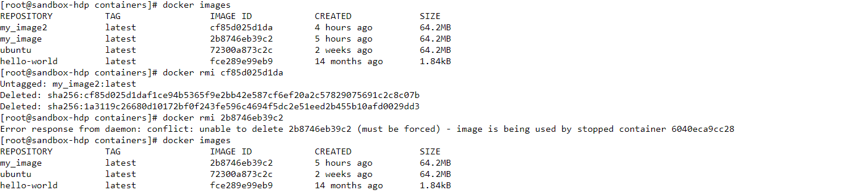

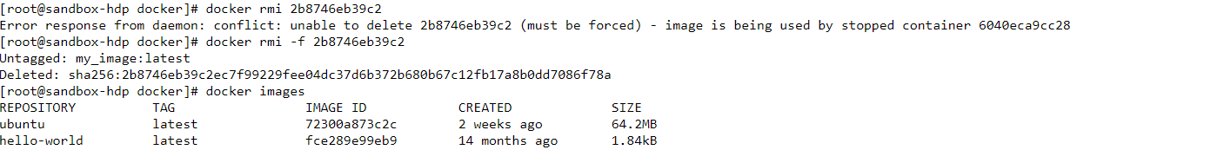

In the above image, I have removed all the docker files to cleanup resources.